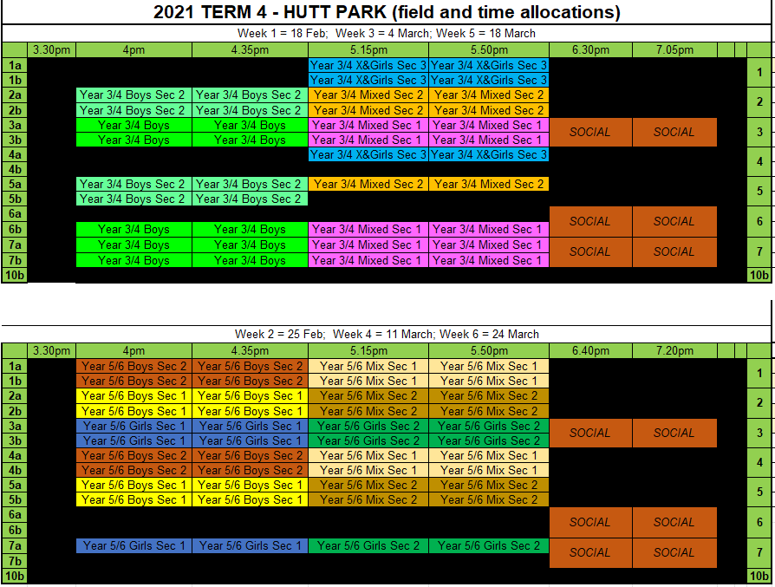

Hutt Park Draw Week 1 18 Feb
Year 3/4 and Adults
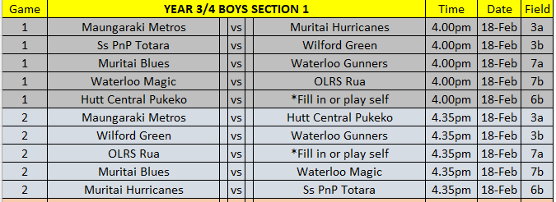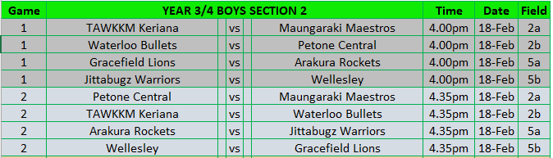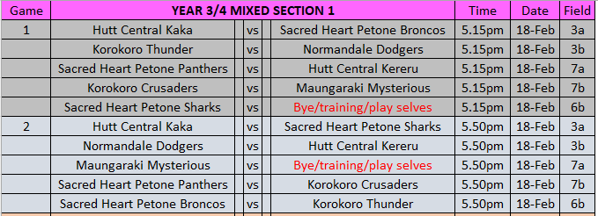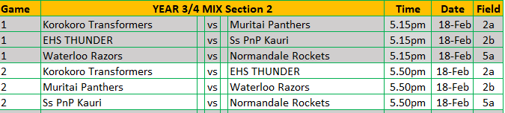
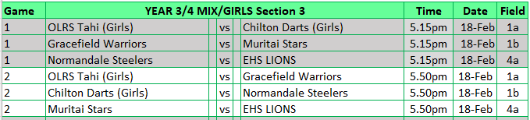
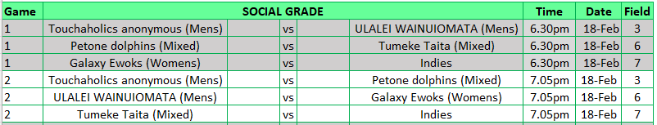

Hutt Park Draw Week 2 25 Feb
Year 5/6
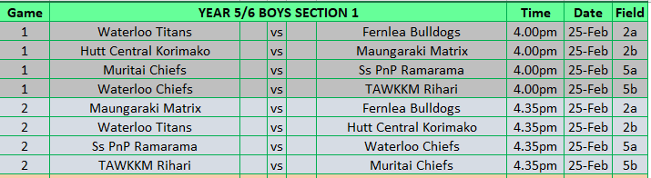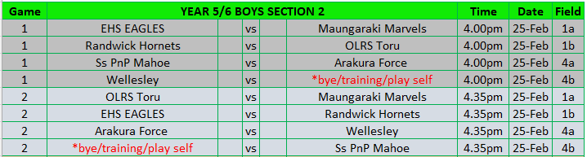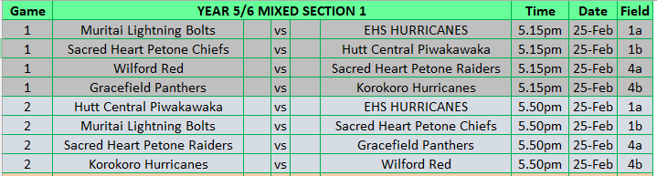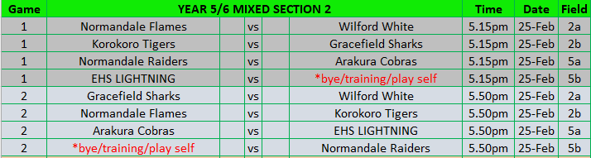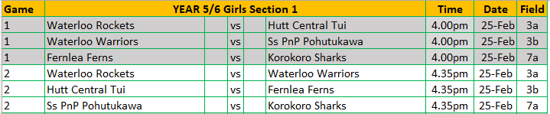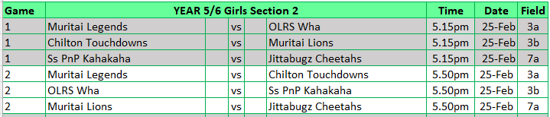

Adults still to be released

